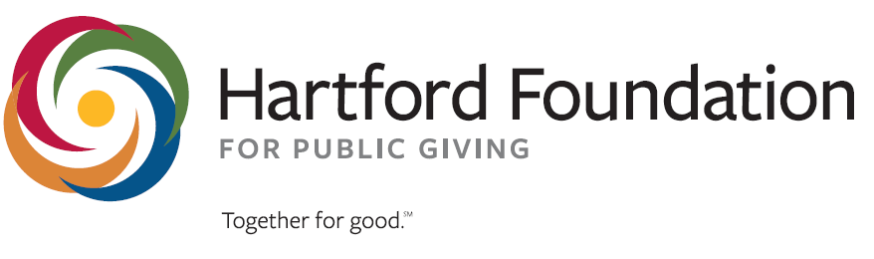
Small Agency Supports

Small Agency Program Supports

The Foundation’s Small Agency program offers both capacity building supports tailored to meet the needs of nonprofits with annual revenues under $200,000.

Hartford Public Library/Hartford Foundation Nonprofit Workshop Series In partnership with the Hartford Public Library we offer about 12 learning opportunities a year for nonprofits focused on some key areas including board roles and responsibilities, strategic thinking, and fundraising. Nonprofits interested in these can find them on the Hartford Public Library website.

Discovery Session A Discovery Session enables smaller or all-volunteer organizations to work with a skilled consultant to focus on one or two key areas that will help the organization move forward. Discovery Sessions include one or two meetings with a skilled facilitator who will provide information and guide discussions focused on the selected topic. Together, your leadership team will explore and decide how to work on the issues identified. You will receive a summary report of the issues and recommendations raised to help guide your future efforts.

Small Agency Grant Program enables small or all-volunteer organizations to access either of two grant types.

- A project grant offering up to $7,500 over one year. Projects must be for a finite period of up to a year and can support direct program or can be used to support a capacity building need.

- Our general operating support grant offers up to $10,000 over two years if the organization has a strategic, annual, or a business plan. Plans must clearly articulate the organization’s goals, objectives, targets, and who’s responsible.

Priority will be given to organizations and programs that align with the Foundation’s focus on dismantling structural racism and achieving equity in social and economic mobility in Greater Hartford's Black and Latinx communities. We seek to achieve that goal through throughour five outcome areas: Higher Opportunity Neighborhoods, Employment Opportunities, Basic Human Needs, Arts and Culture, and Civic and Resident Engagement. For more information about our Small Agency Supports, contact Yvette Bello at ybello@hfpg.org

Other Foundation Supports

Donor Advised Grants – Donor Advised grants are made available through donor advisors at the Hartford Foundaiton. Organizations interested in learning more about these grants should reach out to Reid DiRenzo at RDiRenzo@hfpg.org.

Hartford Foundation Current Grant opportunities (Check the website for the most current list)

Access Grants
Access grants are focued on supporting organizations who have a mission or project idea that could contribute to the goal of dismantling structural racism in Greater Hartford.

Norma and Natale Sestero Fund –
Norma and Natale Sestero Fund grants ranging from $1,000 to $50,000 will be awarded, depending upon the size and maturation of the agency and the scope of work to be performed through the proposed project. Norma and Natale Sestero were longtime residents of Glastonbury. Through their charitable remainder trusts, the Norma and Natale Sestero Fund was established to support organizations that benefit people and institutions from the Town of Glastonbury in the areas of culture, health, education, social welfare and the environment (including town beautification and preservation of heritage).

Community Education on Housing Segregation
Application Deadline: Friday, December 31, 2021 (rolling deadline)
The Community Education on Housing Segregation grant is a competitive grant opportunity designed to engage, educate and organize Greater Hartford residents on issues of housing segregation and pathways to more inclusive housing development in both urban and suburban communities. This Requests for Proposals is available on the Hartford Foundation’s current grant opportunites page.

Giving Circles
Giving Circles are a group of donors who commit to work as a group and decide how best to direct their pooled funds to local nonprofits addressing critical issues in our region. The Foundation has three distinct circles and each manage their giving differently. The Giving Circles are:

LATINO ENDOWMENT FUND This fund helps address the challenges facing Latinx residents and the organizations that serve them. This innovative fund is among the first of its kind in the U.S.

BLACK GIVING CIRCLE FUND This fund promotes meaningful philanthropy within the Black community to support causes that address the needs of the Black community.

CATALYST ENDOWMENT FUND Since it began in 1993, this fund’s endowment has grown to more than $1 million, and the Fund has awarded more than $750,000 to dozens of nonprofits in Greater Hartford.

For more infoarmiton about the Giving Circles, please reach out to Michael Wotorson at mwotorson@hfpg.org.

Nonprofit Support Program Supports

Nonprofit Support Program website – The Nonprofit Support Program website has a ton of useful tools to support a nonprofit organizational development.

Nonprofit Workshops - NSP’s workshops and webinars are designed to deepen your learning and development in key areas of nonprofit management and leadership. Geared primarily toward nonprofit executive directors/CEOs and board leaders, the topics covered may include strategic planning, board performance, fund development, financial management, human resources, technology, evaluation, legal issues and more. Workshops and webinars are free and available to nonprofits that serve the Hartford Foundation’s 29-town region.

Catchafire- The foundation has paid for a number of memberships to Catchafire. Catchafire program connects you with talented professionals looking to give back, allowing you to access expertise in areas such as marketing, web development, operations, strategy, and more.

New England Consultant Directory – Hosed by the Hartford Foundation for Public Giving, the New England Consultant Directory is a tool that can be used by nonprofits to find consultant options to support their capacity building needs.

If you are interested in any of these supports but would like to be directly connected to the appropriate Foundation team member just reach out to Yvette Bello at ybello@hfpg.org

