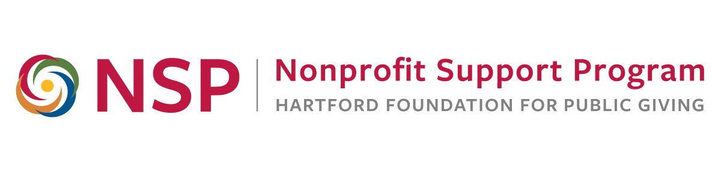
NSP Evaluation Roundtable

Goals:
- Promote ongoing nonprofit discussion, sharing and learning about evaluation
- Provide new and relevant information to meet nonprofit evaluation needs
- Provide a community of practice for area nonprofit and evaluation professionals

Promoting Evaluative Thinking in Your Organization
9:00 to 12:00 a.m., Tuesday, April 9, 2019

Agenda

8:30 – 9:00 Refreshments and Networking
9:00 – 9:40 Welcome and Introductions

Organizational Evaluation Capacity and Evaluative Thinking
Anita Baker, Evaluation Services

9:40 – 10:00 With the End in Mind: Why Evaluation Matters for
Nonprofit Leaders
Jamal Jimerson, Minority Inclusion Project

10:00 – 10:20 Interactive Evaluative Thinking Assessment - Activity

10:20 – 10:30 Break and Networking

10:30 – 10:50 Evaluating a Grants Management System
Sheryl Horowitz, CT Association for Human Services

10:50 – 11:05 Using Evaluative Thinking at the Hartford Foundation
Scott Gaul, Director of Research and Evaluation
Kate Szczerbacki, Research and Evaluation Officer

11:05 – 11:40 Timely Data Collection & Going Beyond the Survey
Rie Poirier-Campbell, Hartford Performs

11:40 – 12:00 Final Intentions, Q/A and Closure
About today’s speakers, in order of appearance…

Anita Baker, Ed.D., Evaluation Services. Anita has worked as an evaluator for over 20 years and is an independent consultant providing a variety of evaluation-related services to research and evaluation organizations, universities, foundations, and non-profit agencies that provide services to youth and families. Since 2006, she has worked closely with the Hartford Foundation for Public Giving providing training to many local area nonprofit organizations. Anita has designed a comprehensive set of evaluation training materials and evaluative thinking assessment tools, which are available, free of charge on her website. She earned her Doctorate in Education from Columbia University, Teacher’s College in 1991, and served as a project director and senior program officer of the Academy for Educational Development in New York City and as a project director at the OMG Center for Collaborative Learning in Philadelphia.

Learn more at: www.evaluationservices.co
Contact: anitabaker@evaluationservices.co

Jamal Jimerson., Minority Inclusion Project. With more than 20 years of experience in the nonprofit world, Jamal Jimerson has worked with organizations of all shapes and sizes in the areas of human resources development, diversity, equity, & inclusion, and leadership. Jamal is the co-founder & Executive Director of Minority Inclusion Project, a nonprofit organization working to close the nonprofit racial leadership gap. He is also the owner and managing partner for Thought Partner Solutions. He has built nonprofit programs from the ground up, expanded organizational capacity, and shaped the public profile of nonprofits with a variety of missions and visions. He has a B.A. in Mass Communications from University of Bridgeport, an M.A. in Business Communications from Trident University, and an M.S. in Human Services from Capella University. In his spare time, Jamal enjoys spending time with his two children and enjoying the arts.

Learn more at: www.ctmip.org
Contact: jamal@ctmip.org

Sheryl Horowitz, CT Association for Human Services. Sheryl came to CAHS in 2010 charged with nurturing an organizational culture that values research and evaluative thinking. Using her background in anthropology as a foundation, Sheryl has worked in medical and social service-based non-profits for over 25 years doing research and evaluation to improve the health and quality of life of low income and marginalized populations. Sheryl received her PhD in Anthropology from the University of Massachusetts, Amherst and completed post-doctoral work at UC Berkeley in Demography and at Stanford University in Population Ecology.

Learn more at www.CAHS.org
Contact: shorowitz@cahs.org

Scott Gaul is Director of Research and Evaluation at the Hartford Foundation, supporting the Foundation and Greater Hartford region by providing research on issues critical to the region and by promoting high-quality evaluation practices. Scott joined the Foundation after serving as director of analysis in the Washington, D.C.-based Microfinance Information Exchange. Prior to that, he worked for the World Bank, Mercy Corps, and Quantitative Risk Management. He holds a master’s degree in international affairs from Johns Hopkins and a bachelor’s degree in mathematics from the University of Chicago.

Kate Szczerbacki is Research and Evaluation Officer at the Hartford Foundation.
Kate worked most recently at The Collaborative for Educational Services, as a Program Evaluation Specialist, where she was involved in several evaluation projects in the Hartford region and in Western Massachusetts. Prior to that, she was a Senior Research Analyst at the UMass Donahue Institute, and a Research Assistant at the Center for Youth and Communities at Brandeis and the Sillerman Center for the Advancement of Philanthropy. She has a JD from the SUNY Buffalo Law School and a PhD in Social Policy from the Heller School at Brandeis University.

Rie Poirier-Campbell, Hartford Performs. Rie’s involvement with Hartford Performs began with its inception as a program of the Greater Hartford Arts Council in 2009. She worked closely with the growing organization until leaving the Arts Council in 2012, and then became Hartford Performs’ Executive Director in 2014. Her 20+ years of nonprofit experience also includes senior leadership positions at the Connecticut Science Center and the former Connecticut Capital Region Growth Council. Prior to that, Rie held marketing and communications positions in the fields of politics, television, real estate development, insurance, government and consumer products.

Learn more at www.HartfordPerforms.org
Contact: RPoirier@HartfordPerforms.org

