

**W O R K S H E E T # 3**

**LABINAR #1**

**SOCIAL**

**ENTERPRISE**

***ACCELERATOR***

**Nonprofit is a Tax Status, Not a Business Model…**

_________

**Why NPO’s Should Care About Earned Income**

April 12, 2023

**W O R K S H E E T # 3**

**Diversifying Revenue:**

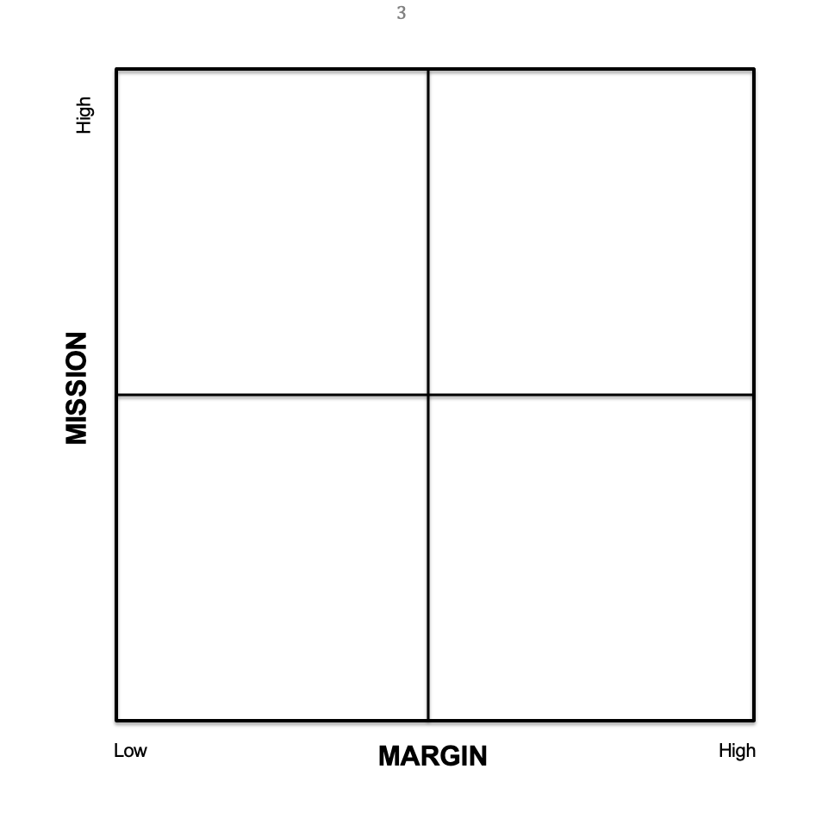***Margin and Mission Matrix***

High

High

Low

**MISSION**

**MARGIN**