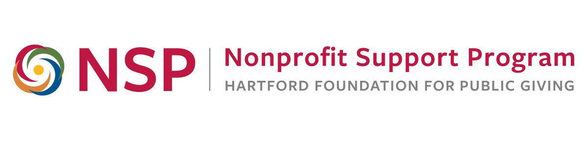
NSP Evaluation Roundtable

Goals:
- Promote ongoing nonprofit discussion, sharing and learning about evaluation
- Provide new and relevant information to meet nonprofit evaluation needs
- Provide a community of practice for area nonprofit and evaluation professionals

Today:
Evaluating Social Media Strategies
9:00 to 11:30 a.m., Wednesday, October 11, 2017

Agenda

8:30 – 9:00 Refreshments and Networking

9:00 – 10:00 Welcome and Introductions

Framing the Issue
Anita Baker, Ed.D., Evaluation Services

Social Media Strategies
Elena Ragusa, Psy.D., DRIVE: Evaluation Partners

10:00 – 10:15 Break and Networking

10:15 – 10:45 Social Media Initiatives
Nancy Scheetz, Executive Director,
Farmington Valley VNA, Inc.

Developing and Evaluating a Social Media Strategy
Amanda Jolly, Program & Membership Manager
World Affairs Council of Connecticut

10:45 – 11:30 Using a Framework to Plan Your Evaluation
Elena Ragusa, Psy.D., DRIVE: Evaluation Partners
Anita Baker, Ed.D., Evaluation Services

Closure

About today’s speakers, in order of appearance…

Anita Baker, Ed.D., Evaluation Services. Anita has worked as an evaluator for over 20 years and is an independent consultant providing a variety of evaluation-related services to research and evaluation organizations, universities, foundations, and non-profit agencies which provide services to youth and families. Since 2006, she has worked closely with the Hartford Foundation for Public Giving providing training to many local area nonprofit organizations. Anita has designed a comprehensive set of evaluation training materials and evaluative thinking assessment tools which are available free of charge on her website. She earned her Doctorate in Education from Columbia University, Teacher’s College in 1991, and served as a project director and senior program officer of the Academy for Educational Development in New York City and as a project director at the OMG Center for Collaborative Learning in Philadelphia.
Learn more at: www.evaluationservices.co
Contact: anitabaker@evaluationservices.co

Elena Tamanas Ragusa, Psy.D, DRIVE: Evaluation Partners. Elena is a consultant and social scientist with extensive experience in quantitative and qualitative research methods, organizational and community psychology, program and systems evaluation, and using data to inform programmatic decision-making. She currently directs pre-college program evaluation for Rutgers University, where she also teaches program evaluation, community psychology, group dynamics, and industrial/organizational psychology. Elena also serves as an independent consultant and evaluator through DRIVE: Evaluation Partners, working collaboratively with non-profit clients to establish realistic outcomes, collect accessible data to measure progress toward them, and tweak programming in response to findings. Elena consults to universities on developing actionable program evaluation designs and has designed and delivered professional development sessions focused on research, evaluation, and metric tracking for non-profit practitioners. Prior to her current work, she served as a project manager at OMG Center for Collaborative Learning (now Equal Measure). Elena earned a Doctorate of Psychology from the Graduate School of Applied and Professional Psychology at Rutgers University.
Follow on Twitter: @ElenaRagusa | Email: elena@driveevaluation.com
Learn more at: http://www.evaluationservices.co/Our_Other_Consultants.html.

Nancy Scheetz, Executive Director, Farmington Valley VNA, Inc.
Nancy has worked as an Advanced Nurse Practitioner for over 33 years, with primary experience practicing Psychiatry. Over the last 2 years, she has shifted her energies to the support of a local non-profit Home Care and Hospice Agency as their Executive Director. Being able to serve her local community and find ways to support a small non-profit organization continues to be a wonderful professional challenge. She earned a Master of Science Degree in Nursing from Russell Sage College for Women in 1987, and has practiced in all healthcare settings, has worked for law enforcement entities, the United States Navy and Marine Corps., as well as having her own Training and Consulting LLC. She has served for many as a Clinical Preceptor, and holds office as a Director for the Connecticut Association of Healthcare at Home.
Learn more at: www.farmingtonvalleyvna.org/
Contact: nscheetz@farmingtonvalleyvna.org

Amanda Jolly, Program & Membership Manager, World Affairs Council of Connecticut
Amanda joined the World Affairs Council of CT in October, 2015 as Program and Membership Manager. Amanda’s interest in global affairs and development economics was first sparked by her participation in the CTWAC’s Model UN program her sophomore year of high school. She then joined the CTWAC community as a Programs intern, and returned again while in college to be an Educational Programs intern. Amanda has since earned her BA in International Service with a focus on U.S. Foreign Policy, graduating magna cum laude with Honors from American University in Washington, DC. Amanda has worked with several non-profits around the globe, from Ghana to the Philippines, and in the U.S., from San Francisco to D.C.
Learn more at: http://www.ctwac.org/ Contact: ajolly@ctwac.org

